**Q. 1 Perform the comparative analysis of microcontrollers and general-purpose microprocessors along with various criteria to choose an appropriate microcontroller for different applications.**

Microcontrollers vs. Microprocessors: A Comparative Analysis

|  |  |  |
| --- | --- | --- |
| **Criteria** | **Microcontroller** | **Microprocessor** |
| **Architecture** | Integrates CPU, memory, I/O peripherals on a single chip | Standalone CPU, external memory, and I/O devices |
| **Complexity** | Less complex, lower clock speeds | More complex, higher clock speeds |
| **Power Consumption** | Lower power consumption due to smaller size and limited functionality | Higher power consumption due to complex architecture and performance demands |
| **Cost** | Lower cost due to smaller chip size and integration | Higher cost due to complex design and additional components |
| **Applications** | Embedded systems, real-time control (e.g., washing machines, drones, sensors) | General-purpose computing (e.g., computers, servers, smartphones) |
| **Memory** | Limited RAM and ROM | Larger RAM and ROM capabilities |
| **Performance** | Lower processing power | Higher processing power |
| **Flexibility** | Limited, tailored for specific tasks | More flexible for diverse tasks |
| **Development Complexity** | Simpler development environment | More complex development environment |
|  |  |  |

**Choosing the Right Microcontroller for your Application:**

*1. Application requirements:*

Processing power: How much computation is needed?

Real-time response: Is quick reaction to inputs crucial?

Power consumption: Does the device need to be battery-powered?

Cost constraints: What is your budget for the MCU?

Peripheral integrations: Does the application require specific features like timers, ADC, or communication modules?

*2. Development environment:*

Ease of use: Are you comfortable with complex development tools?

Software availability: Are libraries and tools available for your chosen MCU?

*3. Future scalability:*

Growth potential: Might your application need more features in the future?

Examples:

Simple sensor project: Choose a low-cost MCU with integrated ADC and communication interface.

High-performance drone: Go for a powerful MCU with advanced motor control capabilities.

Complex industrial controller: Prioritize reliability and real-time response with a robust MCU designed for industrial applications.

**Q.2 Prepare a chart on a brief history of various AVR microcontroller along with standard feature analysis of different variants in context to ATMEGA32.**

**A brief history of the AVR microcontroller**

The basic architecture of AVR was designed by two students of Norwegian

Institute of Technology (NTH), Alf-Egil Bogen and Vegard Wollan, and then was

bought and developed by Atmel in 1996.

You may ask what AVR stands for; AVR can have different meanings for

different people! Atmel says that it is nothing more than a product name, but it

might stand for Advanced Virtual RISC, or Alf and Vegard RISC (the names of the

AVR designers).

There are many kinds of AVR microcontroller with different properties.

Except for AVR32, which is a 32-bit microcontroller, AVRs are all 8-bit microprocessors,

meaning that the CPU can work on only 8 bits of data at a time. Data

larger than 8 bits has to be broken into 8-bit pieces to be processed by the CPU.

One of the problems with the AVR microcontrollers is that they are not all 100%

compatible in terms of software when going from one family to another family. To

run programs written for the ATtiny25 on a ATmega64, we must recompile the

program and possibly change some register locations before loading it into the

ATmega64.

AVRs are generally classified into four broad groups: Mega, Tiny, Special purpose, and Classic. In this text we cover the Mega family because these microcontrollers are widely used. Also, we will focus on ATmega32 since it is

powerful, widely available, and comes in DIP packages, which makes it ideal for

educational purposes. For those who have mastered the Mega family, understandingthe other families is very easy and straightforward.

**AVR features**

The AVR is an 8-bit RISC single-chip microcontroller with Harvard architecture

that comes with some standard features such as on-chip program (code) ROM, data RAM, data EEPROM, timers and I/O ports. See Figure 2. Most AVRs have some additional features like ADC, PWM, and different kinds of serial

interface such as USART, SPI, I2C (TWI), CAN, USB, and so on.

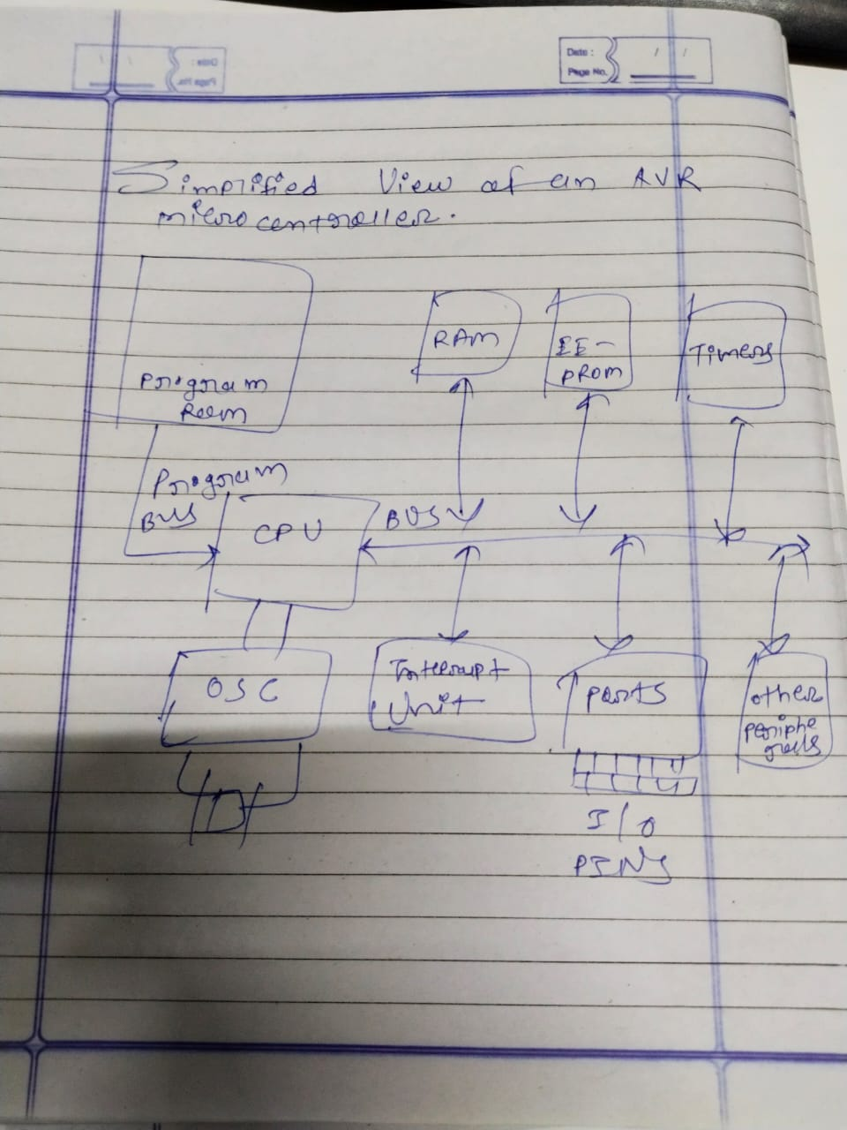

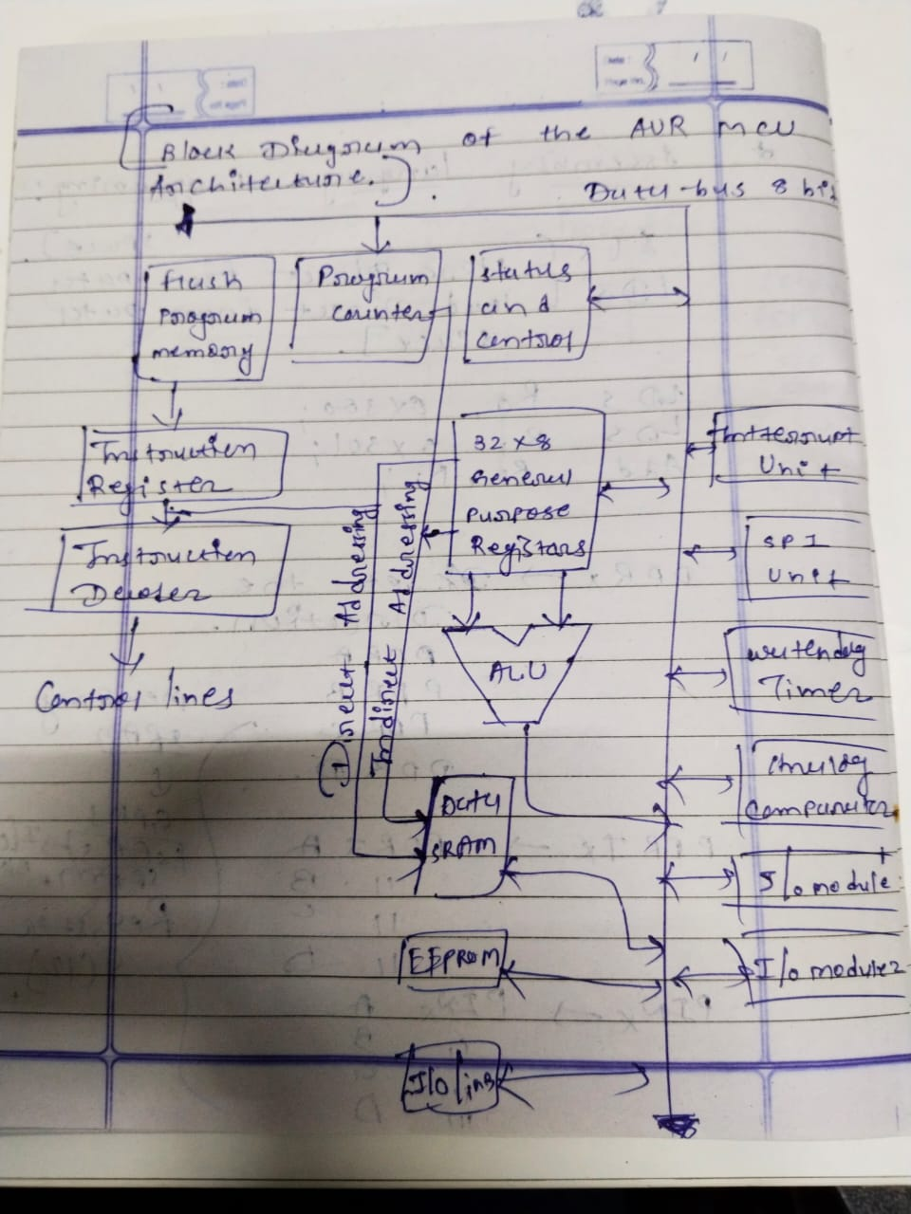

**Q.3 Show following things with suitable diagrams in context to data memory of AVRs**

**a. The Data memory for AVRs with no extended I/O Memory**

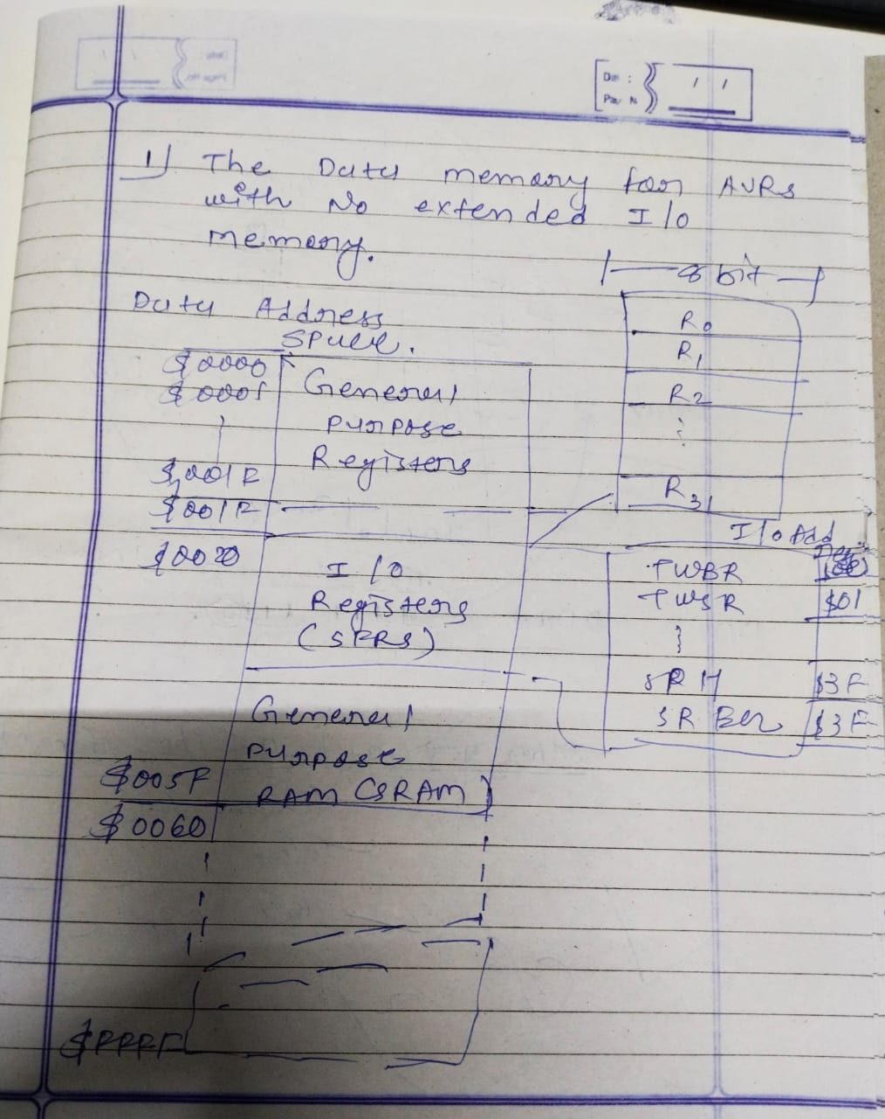

**b. The data memory for AVRs with extended I/O memory**

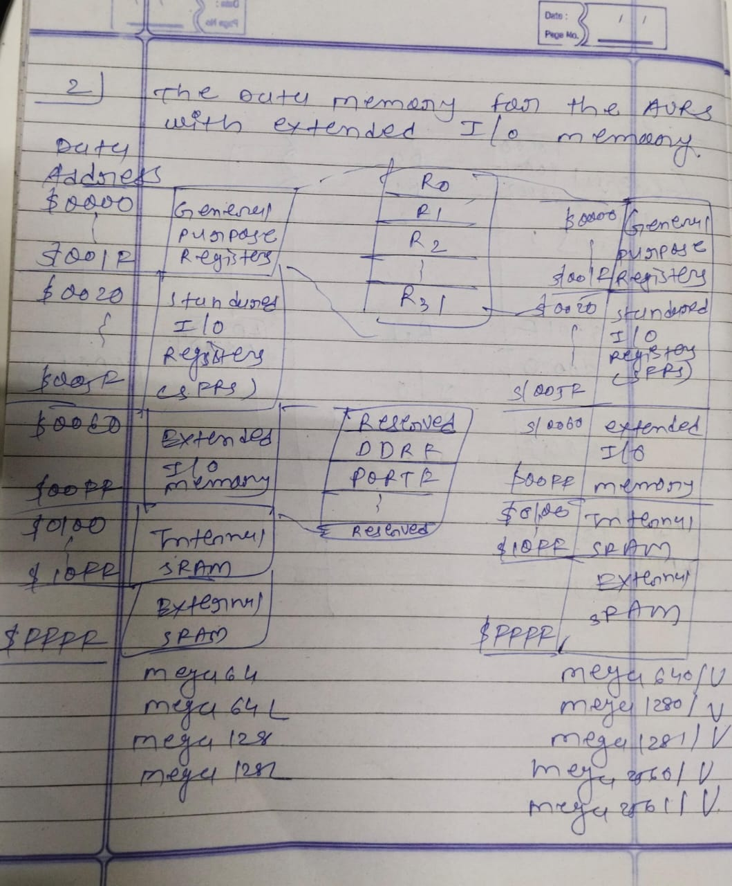

**c. Analyze data memory of different variants of AVR family**

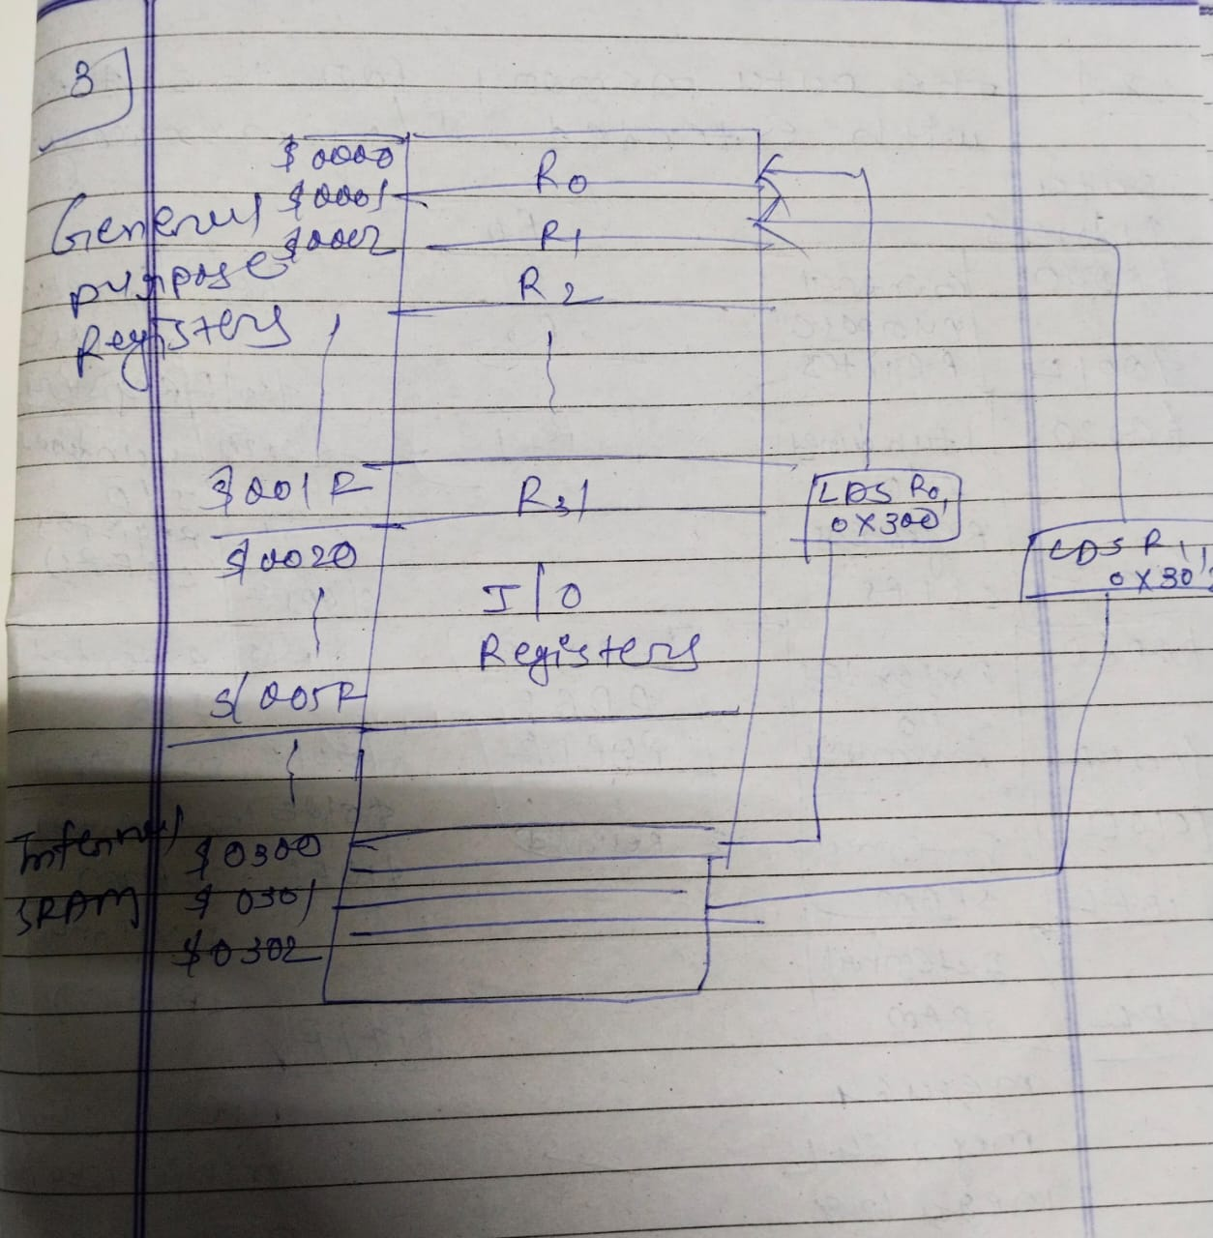

**Q.4 Give the significance of following instructions in terms of their size, formats execution, operation,etc:**

**1. LDI 2. LDS 3. STS 4. IN 5 OUT**

Significance of Instructions based on Size, Format, Execution, and Operation:

***1. LDI:***

Significance: Likely a "Load Immediate" instruction, meaning it loads a constant value directly into a register.

Size: Usually fixed-size, depending on the register width and data type of the architecture.

Format: Often two-operand (register, immediate value).

Execution: Fast, typically single clock cycle.

Operation: Transfers data directly from memory to a register, initializing its value.

***2. LDS:***

Significance: Possible interpretations include:

"Load Direct from Stack": Pushes a value from a register onto the stack.

"Load String": Loads a string from memory into a register.

"Load Data from SRAM": Loads data from a specific memory area.

Size: Varies depending on the specific interpretation and architecture.

Format: Can vary, potentially one-operand (register) or two-operand (register, memory address).

Execution: Depends on the specific implementation, potentially slower than LDI due to memory access.

Operation: Varies depending on the interpretation, either pushing data onto the stack, loading a string from memory, or fetching data from a specific memory region.

***3. STS:***

Significance: Likely a "Store" instruction, saving data from a register to memory.

Size: Usually fixed-size, depending on the register width and data type of the architecture.

Format: Often two-operand (memory address, register).

Execution: Typically slower than LDI due to memory access.

Operation: Writes the value from a register to a specific memory location.

***4. IN:***

Significance: Likely an "Input" instruction, reading data from an external device.

Size: Varies depending on the device and data type.

Format: Can vary, potentially one-operand (register) or two-operand (register, device address).

Execution: Slowest among the listed instructions due to potential delays from external peripherals.

Operation: Transfers data from an external device (e.g., sensor, keypad) to a register.

***5. OUT:***

Significance: Likely an "Output" instruction, sending data to an external device.

Size: Varies depending on the device and data type.

Format: Can vary, potentially one-operand (register) or two-operand (register, device address).

Execution: Similar to IN in terms of speed and potential delays.

Operation: Transfers data from a register to an external device (e.g., display, speaker).

**Q.5 Perform the comparative analysis of RISC and CISC.**

RISC vs. CISC: A Comparative Analysis

|  |  |  |
| --- | --- | --- |
| **Criteria** | **RISC** | **CISC** |
| **Instruction Set** | Fewer, simpler instructions | More, complex instructions |
| **Instruction size** | Fixed-length | Variable-length |
| **Clock cycles per instruction (CPI)** | Lower (ideally 1) | Higher (2-5) |
| **Hardware complexity** | Less complex, more transistors for data processing | More complex, dedicated hardware for complex instructions |
| **Power consumption** | Lower | Higher |
| **Pipeline efficiency** | Highly pipelined | Less pipelined |
| **Memory usage** | More instructions in code | Less code, but may require more data transfers |
| **Cost** | Generally less expensive | Can be more expensive |
| **Development complexity** | Simpler compilers | More complex compilers |
| **Examples** | ARM, MIPS, RISC-V | x86 (Intel, AMD), PowerPC |

**Pros and Cons:**

*RISC:*

Pros: Lower power consumption, faster clock speeds, simpler design, easier pipelining.

Cons: Larger code size, requires more instructions to achieve complex tasks.

*CISC:*

Pros: Compact code, efficient for memory-constrained applications, hardware offloads complex tasks.

Cons: Higher power consumption, slower clock speeds, complex design, challenges in pipelining.

**Q.6 Perform the comparative analysis of Harvard and Von-neuman architectures.**

Harvard vs. Von Neumann Architecture: A Comparative Analysis

|  |  |  |
| --- | --- | --- |
| **Criteria** | **Harvard Architecture** | **Von Neumann Architecture** |
| **Memory organization** | Separate memory spaces for instructions (program memory) and data | Single memory space for both instructions and data |
| **Instruction access** | Dedicated instruction fetch unit | Instructions fetched along with data using the same memory access mechanism |
| **Data access** | Dedicated data access unit | Data accessed through the same memory access mechanism used for instructions |
| **Performance** | Potentially faster due to parallel memory access for instructions and data | Can be slower due to potential contention for the single memory space |
| **Flexibility** | Less flexible, requires specific instructions for data manipulation | More flexible, data can be treated as instructions and vice versa |
| **Complexity** | More complex due to separate memory units and access mechanisms | Simpler design with single memory unit |
| **Cost** | Potentially higher cost due to additional memory and control logic | Lower cost due to simpler design |
| **Examples** | Microcontrollers, DSPs | General-purpose CPUs, GPUs |

**Pros and Cons:**

*Harvard:*

Pros: Faster performance, reduced memory contention, lower power consumption (in some cases).

Cons: Less flexible, more complex and costly design.

*Von Neumann:*

Pros: Simpler design, more flexible data manipulation.

Cons: Can be slower due to memory contention, potentially higher power consumption.